HOME PAGE :

**index.html :**

<!DOCTYPE html>

<html lang="en">

<head>

    <meta charset="UTF-8">

    <meta http-equiv="X-UA-Compatible" content="IE=edge">

    <meta name="viewport" content="width=device-width, initial-scale=1.0">

    <link rel="shortcut icon" href="./static/favicon.ico" type="image/x-icon">

    <link rel="stylesheet" href="./css/index.css">

    <title>Home | Riot Games</title>

</head>

<body>

    <div id="loader">

        <svg xmlns="http://www.w3.org/2000/svg" id="Layer_1" data-name="Layer 1" viewBox="0 0 32 32">

            <circle cx="16" cy="16" r="16" fill="#f1f5f1">

                <animate attributeName="fill" from="#f1f5f1" to="#D13639" dur="1.8s" repeatCount="indefinite" />

            </circle>

            <polygon

                points="16.42 8 6.75 12.47 9.16 21.64 11 21.41 10.49 15.65 11.1 15.38 12.13 21.27 15.27 20.89 14.71 14.53 15.3 14.27 16.45 20.75 19.62 20.36 19.01 13.38 19.61 13.12 20.86 20.2 24 19.82 24 9.89 16.42 8"

                fill="#D13639">

                <animate attributeName="fill" from="#D13639" to="#f1f5f1" dur="1.8s" repeatCount="indefinite" />

            </polygon>

            <polygon points="16.65 21.9 16.81 22.8 24 24 24 21 16.66 21.9 16.65 21.9" fill="#D13639">

                <animate attributeName="fill" from="#D13639" to="#f1f5f1" dur="1.8s" repeatCount="indefinite" />

            </polygon>

        </svg>

    </div>

    <nav class="nav" id="nav">

        <ul class="nav__list">

            <li class="nav__listlogo">

                <a href="/">

                    <svg class="k-logo" viewBox="0 0 587.93 165">

                        <path

                            d="M98.77.33L0 46.07l24.61 93.66 18.73-2.3-5.15-58.89 6.15-2.74L54.96 136l32.01-3.93-5.69-65 6.09-2.71 11.68 66.23 32.38-3.98-6.23-71.25 6.16-2.74 12.77 72.43 32.01-3.93V19.71L98.77.33zm2.32 142.05l1.63 9.22 73.42 12.24v-30.68l-75.01 9.22h-.04zm144.49-19.22v12.63h15.57a14.84 14.84 0 01-1.92 7.31 13 13 0 01-5.6 5.11 20 20 0 01-8.9 1.8 17.53 17.53 0 01-10-2.8 17.87 17.87 0 01-6.44-8.14 33.06 33.06 0 01-2.27-12.93 31.81 31.81 0 012.32-12.81 18.14 18.14 0 016.5-8 17.27 17.27 0 019.82-2.78 19.31 19.31 0 015.36.71 14.15 14.15 0 014.33 2.09 12.92 12.92 0 013.18 3.29 15.61 15.61 0 012 4.44h17.27a27.22 27.22 0 00-3.46-10.28 28.84 28.84 0 00-7.05-8.1 32.6 32.6 0 00-9.91-5.29 37.91 37.91 0 00-12.06-1.86 37.32 37.32 0 00-14 2.6 32.6 32.6 0 00-11.36 7.61 35 35 0 00-7.61 12.21 46.15 46.15 0 00-2.73 16.44q0 11.94 4.54 20.59a32.4 32.4 0 0012.69 13.27 39.84 39.84 0 0035.84.84 28.39 28.39 0 0011.67-11q4.25-7.19 4.24-17.2v-9.76zm215.03 40.81V88.53h51.67v13.96h-34.62v16.76h27.99v13.96h-27.99v16.8h34.7v13.96h-51.75zm101.83-53.3a9 9 0 00-3.54-6.64c-2.09-1.59-5-2.38-8.69-2.38a16.63 16.63 0 00-6.26 1 8.62 8.62 0 00-3.83 2.78 6.74 6.74 0 00-1.33 4 6.2 6.2 0 00.79 3.29 7.27 7.27 0 002.4 2.45 16.54 16.54 0 003.7 1.79 40.14 40.14 0 004.64 1.31l6.63 1.54a47.19 47.19 0 019.45 3.08 27.46 27.46 0 017.2 4.68 18.84 18.84 0 014.58 6.39 20.37 20.37 0 011.61 8.29 20.65 20.65 0 01-3.54 12.11 22.56 22.56 0 01-10.15 7.85 41.31 41.31 0 01-15.93 2.76 42.69 42.69 0 01-16.17-2.81 23.22 23.22 0 01-10.72-8.48q-3.83-5.66-4-14.12h16.43a10.68 10.68 0 007.05 9.94 19.37 19.37 0 007.24 1.26 18.44 18.44 0 006.66-1.09 10 10 0 004.33-3 7.22 7.22 0 001.57-4.48 6.16 6.16 0 00-1.42-4 10.86 10.86 0 00-4.14-2.81 42.07 42.07 0 00-6.89-2.14l-8.07-1.95q-9.65-2.3-15.23-7.26t-5.54-13.44a19.86 19.86 0 013.72-12.12 24.74 24.74 0 0110.33-8.11 36.74 36.74 0 0115-2.91 35.62 35.62 0 0114.92 2.91 23.43 23.43 0 019.91 8.14 21.54 21.54 0 013.6 12.12zm-113.99 53.3h-16.87v-57.35l-1.73-.02-17.04 57.37h-16.86l-16.58-57.37-2.15.02v57.35h-16.87V88.53h28.67l14.48 50.56h1.75l14.48-50.56h28.72v75.44zm-114.66 0h18.27l-25.33-75.43h-23.15l-25.37 75.43h18.3l4.93-16.54h27.42zm-28.43-29.7l8.22-27.65h3.1l8.26 27.65zm278.58-37.76a4 4 0 01-3.67-2.44 4 4 0 010-3.1 4 4 0 01.85-1.27 4.25 4.25 0 011.27-.86 4.15 4.15 0 013.1 0 4.13 4.13 0 011.27.86 4.08 4.08 0 01.86 1.27 4 4 0 010 3.1 4.08 4.08 0 01-.86 1.27 4 4 0 01-1.27.86 4 4 0 01-1.55.31zm0-1.09a2.84 2.84 0 001.47-.39 2.94 2.94 0 001.05-1 2.93 2.93 0 000-2.92 3 3 0 00-1.06-1 2.93 2.93 0 00-2.92 0 3 3 0 00-1 1 2.86 2.86 0 000 2.92 3 3 0 001 1 2.83 2.83 0 001.46.39zm-1.46-1.15V90.6h1.78a1.52 1.52 0 01.69.15 1.13 1.13 0 01.47.42 1.24 1.24 0 01.17.66 1.16 1.16 0 01-.18.66 1 1 0 01-.48.41 1.56 1.56 0 01-.7.14h-1.2v-.72h1a.52.52 0 00.36-.12.5.5 0 00.14-.37.47.47 0 00-.14-.37.52.52 0 00-.36-.12h-.55v2.93zm2.39-1.68l.82 1.68h-1.11l-.75-1.68zM282.41 1.03h17.05v75.44h-17.05zm98.02 37.72q0 12.42-4.71 21a32.67 32.67 0 01-12.79 13.17 38.57 38.57 0 01-36.31 0 32.75 32.75 0 01-12.79-13.2q-4.71-8.66-4.71-21t4.71-21.05a32.67 32.67 0 0112.75-13.14 38.65 38.65 0 0136.31 0 32.67 32.67 0 0112.79 13.17q4.71 8.64 4.71 21.05m-17.35 0a33.35 33.35 0 00-2.23-13 17.47 17.47 0 00-6.33-8 18.57 18.57 0 00-19.45 0 17.57 17.57 0 00-6.35 8 38.59 38.59 0 000 26 17.49 17.49 0 006.35 8 18.57 18.57 0 0019.45 0 17.39 17.39 0 006.33-8 33.4 33.4 0 002.23-13M246.58 50.17l8.76 26.3h18.71l-9.74-28.33h-13.23l-.79-2.44c2.52-.49 6.83-1.25 10.65-3.85a20 20 0 008.75-16.39 24.15 24.15 0 00-3.26-12.75 21.9 21.9 0 00-9.36-8.64 32.56 32.56 0 00-14.64-3H212v75.4h17.06v-26.3zm-.32-15.61a19.35 19.35 0 01-7.26 1.18h-9.94V14.88h9.91a18.68 18.68 0 017.25 1.24 9.12 9.12 0 014.4 3.7 10 10 0 011.5 5.64 9.65 9.65 0 01-1.48 5.55 8.86 8.86 0 01-4.38 3.55M382.04 1.03v14h29.3l.8 2.45c-2.48.48-6.67 1.22-10.43 3.7v55.31h16.87v-61.5h19.62v-14z">

                        </path>

                    </svg>

                </a>

            </li>

            <li class="nav__list-item">

                who we are

                <ul class="nav__list-itemdrop">

                    <li>About Riot</li>

                    <li>Diversity & Inclusion</li>

                    <li>Social Impact</li>

                </ul>

            </li>

            <li class="nav__list-item">

                work with us

                <ul class="nav__list-itemdrop">

                    <li>Jobs</li>

                    <li>Offices</li>

                    <li>Life At Riot</li>

                </ul>

            </li>

            <li class="nav__list-item">news</li>

        </ul>

        <ul class="nav__align-right">

            <li class="nav__align-right__lang">

                <svg xmlns="http://www.w3.org/2000/svg" viewBox="0 0 512 512" class="lang-icon">

                    <path

                        d="M352 256C352 278.2 350.8 299.6 348.7 320H163.3C161.2 299.6 159.1 278.2 159.1 256C159.1 233.8 161.2 212.4 163.3 192H348.7C350.8 212.4 352 233.8 352 256zM503.9 192C509.2 212.5 512 233.9 512 256C512 278.1 509.2 299.5 503.9 320H380.8C382.9 299.4 384 277.1 384 256C384 234 382.9 212.6 380.8 192H503.9zM493.4 160H376.7C366.7 96.14 346.9 42.62 321.4 8.442C399.8 29.09 463.4 85.94 493.4 160zM344.3 160H167.7C173.8 123.6 183.2 91.38 194.7 65.35C205.2 41.74 216.9 24.61 228.2 13.81C239.4 3.178 248.7 0 256 0C263.3 0 272.6 3.178 283.8 13.81C295.1 24.61 306.8 41.74 317.3 65.35C328.8 91.38 338.2 123.6 344.3 160H344.3zM18.61 160C48.59 85.94 112.2 29.09 190.6 8.442C165.1 42.62 145.3 96.14 135.3 160H18.61zM131.2 192C129.1 212.6 127.1 234 127.1 256C127.1 277.1 129.1 299.4 131.2 320H8.065C2.8 299.5 0 278.1 0 256C0 233.9 2.8 212.5 8.065 192H131.2zM194.7 446.6C183.2 420.6 173.8 388.4 167.7 352H344.3C338.2 388.4 328.8 420.6 317.3 446.6C306.8 470.3 295.1 487.4 283.8 498.2C272.6 508.8 263.3 512 255.1 512C248.7 512 239.4 508.8 228.2 498.2C216.9 487.4 205.2 470.3 194.7 446.6H194.7zM190.6 503.6C112.2 482.9 48.59 426.1 18.61 352H135.3C145.3 415.9 165.1 469.4 190.6 503.6V503.6zM321.4 503.6C346.9 469.4 366.7 415.9 376.7 352H493.4C463.4 426.1 399.8 482.9 321.4 503.6V503.6z" />

                </svg>

            </li>

            <li class="nav__align-right__search">

                <input type="text" placeholder="Search" class="search-box" />

                <svg xmlns="http://www.w3.org/2000/svg" viewBox="0 0 512 512" class="search-icon">

                    <path d="M500.3

                    443.7l-119.7-119.7c27.22-40.41 40.65-90.9 33.46-144.7C401.8 87.79 326.8 13.32 235.2

                    1.723C99.01-15.51-15.51 99.01 1.724 235.2c11.6 91.64 86.08 166.7 177.6 178.9c53.8 7.189 104.3-6.236

                    144.7-33.46l119.7 119.7c15.62 15.62 40.95 15.62 56.57 0C515.9 484.7 515.9 459.3 500.3 443.7zM79.1

                    208c0-70.58 57.42-128 128-128s128 57.42 128 128c0 70.58-57.42 128-128 128S79.1 278.6 79.1

                    208z" />

                </svg>

            </li>

            <li class="nav__align-right__signin">

                <a href="#">sign in</a>

            </li>

        </ul>

    </nav>

    <div class="section-container" id="section1">

        <section class="section-container__1">

            <img src="./static/annie-tibber-statue-day.png" alt="annie-tibber-statue" />

        </section>

        <section class="section-container__2">

            <p>What's happening?</p>

            <button>See more</button>

            <div class="section-container__2__span_2-5">

                <div class="section-container__2__span_2-5__card"

                    onclick="window.open('https*:*//www.riotgames.com/en/news/player-dynamics-design-looking-behind-the-curtain', '_blank');">

                    <img src="./static/arcade-riven-vs-blitz-splash.jpg" alt="arcade-riven-vs-blitz-splash"

                        class="section-container__2__span_2-5__card__img" />

                    <div class="section-container__2__span_2-5__card__text">

                        <svg class="Layer_1" viewBox="0 0 185.47 163.51">

                            <path class="cls-1" fill="#f1f5f1"

                                d="M98.77 0L0 45.74l24.61 93.66 18.73-2.3-5.15-58.89 6.15-2.74 10.62 60.2 32.01-3.93-5.69-65 6.09-2.71 11.68 66.23 32.38-3.98-6.23-71.25 6.16-2.74 12.77 72.43 32.01-3.93V19.38L98.77 0zM101.09 142.05l1.63 9.22 73.42 12.24v-30.68l-75.01 9.21-.04.01z">

                            </path>

                        </svg>

                        <h2>Player Dynamics Design: Looking Behind the Curtain</h2>

                        <h3>NEWS</h3>

                    </div>

                </div>

            </div>

            <div class="section-container__2__col-4-cards">

                <div class="section-container__2__col-4-cards-1"

                    onclick="window.open('https*:*//www.riotgames.com/en/news/two-riot-initiatives-honored-by-fast-company', '_blank');">

                    <div class="section-container__2__col-4-cards-1__content">

                        <p>Two Riot Initiatives Honored by Fast Company</p>

                        <p class="section-container__2__col-4-cards-1__content__caption">NEWS</p>

                    </div>

                    <div class="section-container__2__col-4-cards-1__makeSlant"></div>

                    <div class="section-container__2__col-4-cards-1__mainImage-1">

                        <svg class="Layer_1" viewBox="0 0 185.47 163.51">

                            <path class="cls-1" fill="#f1f5f1"

                                d="M98.77 0L0 45.74l24.61 93.66 18.73-2.3-5.15-58.89 6.15-2.74 10.62 60.2 32.01-3.93-5.69-65 6.09-2.71 11.68 66.23 32.38-3.98-6.23-71.25 6.16-2.74 12.77 72.43 32.01-3.93V19.38L98.77 0zM101.09 142.05l1.63 9.22 73.42 12.24v-30.68l-75.01 9.21-.04.01z">

                            </path>

                        </svg>

                    </div>

                </div>

                <div class="section-container__2__col-4-cards-2"

                    onclick="window.open('https*:*//www.riotgames.com/en/news/womens-history-month-2022', '_blank');">

                    <div class="section-container__2__col-4-cards-2__content">

                        <p>Women's History Month</p>

                        <p class="section-container__2__col-4-cards-2__content__caption">INSIDE RIOT</p>

                    </div>

                    <div class="section-container__2__col-4-cards-2__makeSlant"></div>

                    <div class="section-container__2__col-4-cards-2__mainImage-2">

                        <svg class="Layer_1" viewBox="0 0 185.47 163.51">

                            <path class="cls-1" fill="#f1f5f1"

                                d="M98.77 0L0 45.74l24.61 93.66 18.73-2.3-5.15-58.89 6.15-2.74 10.62 60.2 32.01-3.93-5.69-65 6.09-2.71 11.68 66.23 32.38-3.98-6.23-71.25 6.16-2.74 12.77 72.43 32.01-3.93V19.38L98.77 0zM101.09 142.05l1.63 9.22 73.42 12.24v-30.68l-75.01 9.21-.04.01z">

                            </path>

                        </svg>

                    </div>

                </div>

                <div class="section-container__2__col-4-cards-3"

                    onclick="window.open('https*:*//www.riotgames.com/en/news/how-rioters-in-brazil-helped-create-raze-the-dancing-salvadorian-duelist', '_blank');">

                    <div class="section-container__2__col-4-cards-3__content">

                        <p>How Rioters in Brazil Helped Create Raze, the Dancing Salvadorian Duelist</p>

                        <p class="section-container__2__col-4-cards-3__content__caption">INSIDE RIOT</p>

                    </div>

                    <div class="section-container__2__col-4-cards-3__makeSlant"></div>

                    <div class="section-container__2__col-4-cards-3__mainImage-3">

                        <svg viewBox="0 0 20 20" fill="none">

                            <path

                                d="M18 3.7v6.059c0 .096-.034.19-.096.265l-1.55 1.888a.44.44 0 0 1-.342.16h-4.91c-.086 0-.133-.097-.08-.162l6.797-8.273c.06-.073.181-.032.181.062zM7.202 16.24l-5.106-6.216A.417.417 0 0 1 2 9.76v-6.06c0-.094.122-.135.181-.062l10.352 12.601c.053.065.006.162-.08.162h-4.91a.44.44 0 0 1-.341-.16z">

                            </path>

                        </svg>

                    </div>

                </div>

                <div class="section-container__2__col-4-cards-4"

                    onclick="window.open('https*:*//www.riotgames.com/en/news/riot-games-announces-new-equity-investment-in-arcane-animation-studio-fortiche-production', '_blank');">

                    <div class="section-container__2__col-4-cards-4__content">

                        <p>Riot Games Announces New Equity Investment in “Arcane” Animation Studio Fortiche Production

                        </p>

                        <p class="section-container__2__col-4-cards-4__content__caption">NEWS</p>

                    </div>

                    <div class="section-container__2__col-4-cards-4__makeSlant"></div>

                    <div class="section-container__2__col-4-cards-4__mainImage-4">

                        <svg class="Layer_1" viewBox="0 0 185.47 163.51">

                            <path class="cls-1" fill="#f1f5f1"

                                d="M98.77 0L0 45.74l24.61 93.66 18.73-2.3-5.15-58.89 6.15-2.74 10.62 60.2 32.01-3.93-5.69-65 6.09-2.71 11.68 66.23 32.38-3.98-6.23-71.25 6.16-2.74 12.77 72.43 32.01-3.93V19.38L98.77 0zM101.09 142.05l1.63 9.22 73.42 12.24v-30.68l-75.01 9.21-.04.01z">

                            </path>

                        </svg>

                    </div>

                </div>

            </div>

        </section>

        <section class="section-container__3">

            <p class="our-games">Our Games</p>

            <div class="section-container__3__cards">

                <div class="section-container__3__cards__row_1">

                    <div class="lol text" style="margin-left: 10%;">

                        <span>LEAGUE</span>

                        <span class="lower-capital">OF</span>

                        <span>LEGENDS</span>

                    </div>

                    <div class="valorant text" style="margin-left: 6%; ">

                        <p>VALORANT</p>

                    </div>

                    <div class="section-container__3__cards__img__container"

                        onclick="window.open('https*:*//www.leagueoflegends.com', '_blank');">

                        <img src="./static/Games/1.jpg" alt="lol" style="margin-left: 10%; margin-top: 10px" />

                    </div>

                    <div class="section-container__3__cards__img__container" style="margin-left: 6%; margin-top: 10px"

                        onclick="window.open('https*:*//playvalorant.com/en-us/', '_blank');">

                        <img src="./static/Games/2.webp" alt="valo" />

                    </div>

                </div>

                <div class="section-container__3__cards__row_2">

                    <div class="tft text">

                        <span>

                            <span class="big-t">T</span>EAMFIGHT <span class="big-t">T</span>ACTICS

                        </span>

                    </div>

                    <div class="lolw text">

                        <span>LEAGUE</span><span class="lower-capital">OF</span><span>LEGENDS</span>

                        <span class="wildrift">WILDRIFT</span>

                    </div>

                    <div class="lor text">

                        <span>LEGENDS OF&nbsp;</span><span class="runeterra">RUNETERRA</span>

                    </div>

                    <div class="section-container__3__cards__img__container"

                        onclick="window.open('https*:*//teamfighttactics.leagueoflegends.com/', '_blank');">

                        <img src="./static/Games/3.jpg" alt="lolw" />

                    </div>

                    <div class="section-container__3__cards__img__container"

                        onclick="window.open('https*:*//wildrift.leagueoflegends.com/', '_blank');">

                        <img src="./static/Games/4.webp" alt="tft" />

                    </div>

                    <div class="section-container__3__cards__img__container"

                        onclick="window.open('https*:*//playruneterra.com/en-us/', '_blank');">

                        <img src="./static/Games/5.jpg" alt="lor" />

                    </div>

                </div>

                <div class="section-container__3__cards__row_3">

                    <div class="rk text">

                        <span><span class="caps">R</span>UINED KIN<span class="caps">G</span></span>

                    </div>

                    <div class="hm text">

                        <span>HEXTECH MAYHEM</span>

                    </div>

                    <div class="convrgence text">

                        <span>CONVRGENCE</span>

                    </div>

                    <div class="section-container__3__cards__img__container"

                        onclick="window.open('https*:*//ruinedking.com/en-us/', '_blank');">

                        <img src="./static/Games/6.jpg" alt="rk" />

                    </div>

                    <div class="section-container__3__cards__img__container"

                        onclick="window.open('https*:*//hextechmayhem.com/en-gb/', '_blank');">

                        <img src="./static/Games/7.webp" alt="hm" />

                    </div>

                    <div class="section-container__3__cards__img__container"

                        onclick="window.open('https*:*//convrgencegame.com/', '_blank');">

                        <img src="./static/Games/8.jpg" alt="convrgence" />

                    </div>

                </div>

                <div class="section-container__3__cards__row_4">

                    <div></div>

                    <div class="son text">

                        <span><span class="caps">S</span>ONG<span class="lower-capital">OF</span><span

                                class="caps">N</span>UNU</span>

                    </div>

                    <div></div>

                    <div></div>

                    <div class="section-container__3__cards__img__container"

                        onclick="window.open('https*:*//songofnunu.com/en-gb/', '_blank');">

                        <img src="./static/Games/9.jpg" alt="son" />

                    </div>

                    <div></div>

                </div>

            </div>

        </section>

        <section class="section-container__4">

            <div class="section-container__4__slantCardContainer">

                <div class="section-container__4__slantCardContainer__slantCard1"></div>

                <div class="section-container__4__slantCardContainer__wrapText">

                    <div class="section-container__4__slantCardContainer__wrapText__makeSlant"></div>

                    <p class="hiring">

                        We're hiring!

                    </p>

                    <p class="hiring-caption">

                        Team up with Riot to forge your path and craft unforgettable experiences for players

                    </p>

                    <div class="section-container__4__slantCardContainer__wrapText__makeSlant__cards">

                        <div class="section-container__4__slantCardContainer__wrapText__makeSlant__cards__card">

                            <p class="number-count">594</p>

                            <p class="designation">Open positions</p>

                        </div>

                        <div class="section-container__4__slantCardContainer__wrapText__makeSlant__cards__card">

                            <p class="number-count">24</p>

                            <p class="designation">Offices</p>

                        </div>

                    </div>

                    <div class="explore-careers">

                        <button onclick="window.open('https*:*//www.riotgames.com/en/work-with-us', '_blank');">Explore

                            Careers</button>

                    </div>

                </div>

                <div class="section-container__4__slantCardContainer__imageSlant"></div>

            </div>

        </section>

        <section class="section-container__5">

            <div class="footer">

                <div class="footer-logo">

                    <a href="/">

                        <svg viewBox="0 0 185.47 163.51" class="footer-logo-1">

                            <path

                                d="M98.77 0L0 45.74l24.61 93.66 18.73-2.3-5.15-58.89 6.15-2.74 10.62 60.2 32.01-3.93-5.69-65 6.09-2.71 11.68 66.23 32.38-3.98-6.23-71.25 6.16-2.74 12.77 72.43 32.01-3.93V19.38L98.77 0zM101.09 142.05l1.63 9.22 73.42 12.24v-30.68l-75.01 9.21-.04.01z">

                            </path>

                        </svg>

                    </a>

                </div>

                <div class="footer-content">

                    <ul>

                        <li><a href="">press</a></li>

                        <li><a href="">security</a></li>

                        <li><a href="">legal</a></li>

                        <li><a href="">leadership</a></li>

                        <li><a href="">candidate privacy</a></li>

                        <li><a href="">terms of service</a></li>

                        <li><a href="">privacy notice</a></li>

                        <li><a href="">player support</a></li>

                        <li><a href="">e-verify</a></li>

                        <li><a href="">accessibility</a></li>

                    </ul>

                </div>

                <div class="social-handles">

                    <a href="https://www.facebook.com/RiotGames/" target="_blank">

                        <svg xmlns="http://www.w3.org/2000/svg" viewBox="0 0 320 512">

                            <path

                                d="M279.14 288l14.22-92.66h-88.91v-60.13c0-25.35 12.42-50.06 52.24-50.06h40.42V6.26S260.43 0 225.36 0c-73.22 0-121.08 44.38-121.08 124.72v70.62H22.89V288h81.39v224h100.17V288z" />

                        </svg>

                    </a>

                    <a href="https://twitter.com/riotgames" target="_blank">

                        <svg xmlns="http://www.w3.org/2000/svg" viewBox="0 0 512 512">

                            <path

                                d="M459.37 151.716c.325 4.548.325 9.097.325 13.645 0 138.72-105.583 298.558-298.558 298.558-59.452 0-114.68-17.219-161.137-47.106 8.447.974 16.568 1.299 25.34 1.299 49.055 0 94.213-16.568 130.274-44.832-46.132-.975-84.792-31.188-98.112-72.772 6.498.974 12.995 1.624 19.818 1.624 9.421 0 18.843-1.3 27.614-3.573-48.081-9.747-84.143-51.98-84.143-102.985v-1.299c13.969 7.797 30.214 12.67 47.431 13.319-28.264-18.843-46.781-51.005-46.781-87.391 0-19.492 5.197-37.36 14.294-52.954 51.655 63.675 129.3 105.258 216.365 109.807-1.624-7.797-2.599-15.918-2.599-24.04 0-57.828 46.782-104.934 104.934-104.934 30.213 0 57.502 12.67 76.67 33.137 23.715-4.548 46.456-13.32 66.599-25.34-7.798 24.366-24.366 44.833-46.132 57.827 21.117-2.273 41.584-8.122 60.426-16.243-14.292 20.791-32.161 39.308-52.628 54.253z" />

                        </svg>

                    </a>

                    <a href="https://www.linkedin.com/company/riot-games/" target="_blank">

                        <svg xmlns="http://www.w3.org/2000/svg" viewBox="0 0 448 512">

                            <path

                                d="M100.28 448H7.4V148.9h92.88zM53.79 108.1C24.09 108.1 0 83.5 0 53.8a53.79 53.79 0 0 1 107.58 0c0 29.7-24.1 54.3-53.79 54.3zM447.9 448h-92.68V302.4c0-34.7-.7-79.2-48.29-79.2-48.29 0-55.69 37.7-55.69 76.7V448h-92.78V148.9h89.08v40.8h1.3c12.4-23.5 42.69-48.3 87.88-48.3 94 0 111.28 61.9 111.28 142.3V448z" />

                        </svg>

                    </a>

                    <a href="https://www.youtube.com/riotgames" target="_blank">

                        <svg xmlns="http://www.w3.org/2000/svg" viewBox="0 0 576 512">

                            <path

                                d="M549.655 124.083c-6.281-23.65-24.787-42.276-48.284-48.597C458.781 64 288 64 288 64S117.22 64 74.629 75.486c-23.497 6.322-42.003 24.947-48.284 48.597-11.412 42.867-11.412 132.305-11.412 132.305s0 89.438 11.412 132.305c6.281 23.65 24.787 41.5 48.284 47.821C117.22 448 288 448 288 448s170.78 0 213.371-11.486c23.497-6.321 42.003-24.171 48.284-47.821 11.412-42.867 11.412-132.305 11.412-132.305s0-89.438-11.412-132.305zm-317.51 213.508V175.185l142.739 81.205-142.739 81.201z" />

                        </svg>

                    </a>

                </div>

            </div>

            <hr />

            <div class="other-content">

                <span>Cookie Preferences | &copy; 2022 Riot Games, Inc. All Rights Reserved.</span>

                <span class="go-up">

                    TO THE SURFACE

                    <a href="">

                        <svg xmlns="http://www.w3.org/2000/svg" viewBox="0 0 448 512">

                            <path

                                d="M416 352c-8.188 0-16.38-3.125-22.62-9.375L224 173.3l-169.4 169.4c-12.5 12.5-32.75 12.5-45.25 0s-12.5-32.75 0-45.25l192-192c12.5-12.5 32.75-12.5 45.25 0l192 192c12.5 12.5 12.5 32.75 0 45.25C432.4 348.9 424.2 352 416 352z" />

                        </svg>

                    </a>

            </div>

        </section>

    </div>

</body>

<script src="./js/index.js"></script>

</html>

**index.css :**

@import url(https://fonts.googleapis.com/css?family=Oswald:200,300,regular,500,600,700);

@font-face {

  font-family: "son";

  src: url("../fonts/FRGROT.TTF") format("truetype");

}

@font-face {

  font-family: "rk";

  src: url("../fonts/NocturneSerif-Regular.ttf") format("truetype");

}

@font-face {

  font-family: "lor";

  src: url("../fonts/Prince of Darkness Regular.otf") format("opentype");

}

@font-face {

  font-family: "wildrift";

  src: url("../fonts/Story Brush Slanted.otf") format("opentype");

}

@font-face {

  font-family: "tft";

  src: url("../fonts/Beaufort W01 Regular.ttf") format("truetype");

}

@font-face {

  font-family: "valorant";

  src: url("../fonts/Valorant Font.ttf") format("truetype");

}

@font-face {

  font-family: "lol";

  src: url("../fonts/Friz Quadrata Regular.ttf") format("truetype");

}

@font-face {

  font-family: "FF Mark";

  src: url("../fonts/FontFont_FF.Mark.Pro.otf") format("opentype");

}

@font-face {

  font-family: "Mark Pro";

  src: url("../fonts/Mark Pro.ttf") format("truetype");

}

html {

  scroll-behavior: smooth;

}

* {

  margin: 0;

  padding: 0;

  box-sizing: border-box;

  font-family: "FF Mark";

}

*::selection {

  background: #d13639;

  color: #f9f9f9;

}

#loader {

  position: absolute;

  top: 50%;

  left: 50%;

  transform: translate(-50%, -50%);

}

#loader svg {

  width: 15rem;

  height: 15rem;

}

.nav {

  display: flex;

  align-items: center;

  position: fixed;

  width: 100vw;

  background-color: #111111;

  color: #f9f9f9;

  z-index: 999;

}

.nav__list {

  display: flex;

  align-items: center;

  gap: 3.3rem;

  margin: 1rem;

}

.nav__listlogo {

  list-style: none;

}

.nav__listlogo .k-logo {

  transition: fill 200ms ease-in-out;

  font-size: 13px;

  height: 27px;

  width: 85px;

  fill: #f9f9f9;

  cursor: pointer;

}

.nav__listlogo .k-logo:hover {

  fill: #d13639;

  cursor: pointer;

}

.nav__list-item {

  list-style: none;

  position: relative;

  font-size: 13px;

  text-transform: uppercase;

  letter-spacing: 1px;

  cursor: pointer;

}

.nav__list-item:not(:last-child)::after {

  content: "";

  position: absolute;

  border-left: 0.35rem solid transparent;

  border-right: 0.35rem solid transparent;

  border-top: 0.35rem solid #7e7e7e;

  top: 50%;

  margin-left: 5px;

  transform: translateY(-80%);

}

.nav__list-item:hover {

  text-decoration: 2px underline #d13639;

  text-underline-offset: 0.5rem;

  transition: text-decoration 200ms ease-in-out;

}

.nav__list-item:hover ul,

.nav__list-item:focus ul {

  opacity: 1;

  visibility: visible;

}

.nav__list-itemdrop {

  display: flex;

  flex-direction: column;

  width: 9rem;

  position: absolute;

  top: 200%;

  background: #222222;

  border-radius: 0 0 5px 5px;

  box-shadow: 0 0 10px rgba(0, 0, 0, 0.5);

  opacity: 0;

  visibility: hidden;

  transition: opacity 200ms ease-in-out, visibility 200ms ease-in-out;

}

.nav__list-itemdrop li {

  margin: 0.5rem;

  text-transform: capitalize;

  list-style: none;

  padding: 0.5rem;

  transition: *background* 200ms ease-in-out;

}

.nav__list-itemdrop li:hover {

  background: #333333;

  border-radius: 5px;

  color: #c7c7c7;

  cursor: pointer;

}

.nav__align-right {

  list-style: none;

  display: flex;

  flex-direction: row;

  position: absolute;

  right: 0;

  justify-content: flex-end;

  align-items: center;

}

.nav__align-right__lang .lang-icon {

  height: 1.2rem;

  width: 1.2rem;

  fill: #f9f9f9;

  cursor: pointer;

  margin-right: 1rem;

}

.nav__align-right__search {

  display: flex;

  width: 12rem;

  background-color: #2b2a29;

  padding: 0.5rem 0.3rem 0.5rem 1.2rem;

  border-radius: 50px;

  align-items: center;

  margin-right: 1rem;

  z-index: 9999;

}

.nav__align-right__search .search-icon {

  margin-right: 0.4rem;

  height: 1.3rem;

  width: 1.3rem;

  fill: #fff;

  cursor: pointer;

}

.nav__align-right__search .search-box {

  color: #f9f9f9;

  border: none;

  font-size: 0.7rem;

  outline: none;

  background-color: #2b2a29;

  width: 100%;

}

.nav__align-right__search .search-box::placeholder {

  color: #757575;

  text-transform: uppercase;

}

.nav__align-right__signin {

  background-color: #d13639;

  color: #111111;

  padding: 0.7rem 0.6rem;

  border-radius: 50px;

  margin-right: 2rem;

  padding: 0.6rem 1rem;

  cursor: pointer;

}

.nav__align-right__signin a {

  letter-spacing: 1px;

  font-size: 0.7rem;

  vertical-align: middle;

  text-transform: uppercase;

  color: inherit;

  text-decoration: none;

  font-weight: bold;

}

.nav__align-right__signin:hover {

  background-color: #f9f9f9;

  color: #d13639;

  transition: background-color 200ms ease-in-out;

}

.section-container__1 img {

  width: 100%;

  line-break: 0;

  filter: brightness(0.7);

}

.section-container__2 {

  margin-top: -5px;

  background: #0a0a0a;

  z-index: -999;

  color: #f9f9f9;

  display: grid;

  grid-template-columns: 57% 43%;

  padding-bottom: 5.5rem;

}

.section-container__2>p {

  margin: 4rem;

  font-size: 48px;

  font-weight: bold;

}

.section-container__2 button {

  display: flex;

  justify-self: flex-end;

  align-self: center;

  width: fit-content;

  height: fit-content;

  padding: 0.4rem 0.9rem;

  text-transform: uppercase;

  margin-right: 4rem;

  background-color: #222222;

  outline: none;

  border: none;

  letter-spacing: 1px;

  font-size: 0.75rem;

  font-weight: bold;

  color: #f9f9f9;

  border-radius: 5px;

  cursor: pointer;

}

.section-container__2__span_2-5__card {

  user-select: none;

  position: relative;

  margin-left: 4rem;

  cursor: pointer;

}

.section-container__2__span_2-5__card img {

  width: 98.5%;

  border-radius: 12px;

  height: 18.9rem;

  object-fit: cover;

  padding: 0.2rem;

}

.section-container__2__span_2-5__card__text {

  position: absolute;

  top: 0;

  left: 0;

  height: 98.8%;

  width: 98.5%;

  display: flex;

  justify-content: flex-end;

  flex-direction: column;

  padding: 0 0 1rem 1rem;

}

.section-container__2__span_2-5__card__text .Layer_1 {

  position: absolute;

  top: 1rem;

  left: 1rem;

  height: 2rem;

  width: 2rem;

  fill: #f9f9f9;

  cursor: pointer;

  border-radius: 50%;

  padding: 0.5rem;

  background-color: #141212;

}

.section-container__2__span_2-5__card__text:hover {

  outline: 2px solid gray;

  border-radius: 12px;

}

.section-container__2__span_2-5__card__text h2 {

  font-size: 31px;

  font-weight: bold;

  letter-spacing: 0.1px;

}

.section-container__2__span_2-5__card__text h3 {

  font-size: 15px;

  color: #5d5c5a;

  font-weight: bold;

}

.section-container__2__col-4-cards {

  margin-right: 4rem;

}

.section-container__2__col-4-cards>div {

  line-height: 1.2;

  letter-spacing: 0.5px;

  color: #f9f9f9;

  font-family: "Mark Pro" !important;

  font-size: 18px;

  font-weight: 700;

  position: relative;

  height: 120px;

  width: 100%;

  background: #2b2a29;

  display: flex;

  background-color: transparent;

  cursor: pointer;

  padding: 3px;

}

.section-container__2__col-4-cards>div:hover {

  outline: 2px solid gray;

  border-radius: 12px;

}

.section-container__2__col-4-cards>div:not(:first-child) {

  margin-top: 0.4rem;

}

.section-container__2__col-4-cards>div>div:nth-child(2) {

  height: 100%;

  box-sizing: border-box;

  border-left: 50px solid #2b2a29;

  border-bottom: 114px solid transparent;

  margin-left: -3px;

  z-index: 99;

}

.section-container__2__col-4-cards-1 {

  user-select: none;

}

.section-container__2__col-4-cards-1__content {

  border-top-left-radius: 12px;

  border-bottom-left-radius: 12px;

  padding: 1.5rem 0 0 1.5rem;

  color: white;

  width: 60%;

  height: 100%;

  background: #2b2a29;

  box-sizing: border-box;

}

.section-container__2__col-4-cards-1__content p:first-child {

  height: 40px;

  overflow: hidden;

  text-overflow: ellipsis;

}

.section-container__2__col-4-cards-1__content p:last-child {

  font-size: 0.88rem;

  margin-top: 0.5rem;

  color: #5e5d5b;

  letter-spacing: 0.5px;

  font-weight: 700;

}

.section-container__2__col-4-cards-1__mainImage-1 {

  position: absolute;

  margin-right: 3px;

  /* adding card-pad-section-2 */

  height: calc(100% - 6px);

  /* subtract 2*(card-pad-section-2) from 100% */

  width: 40%;

  right: 0;

  border-top-right-radius: 12px;

  border-bottom-right-radius: 12px;

  background: url("../static/rg-fastco-award.png") no-repeat;

  background-size: cover;

}

.section-container__2__col-4-cards-1__mainImage-1 svg {

  position: absolute;

  height: 2rem;

  width: 2rem;

  fill: #f9f9f9;

  cursor: pointer;

  right: 0;

  margin: 0.4rem 0.4rem 0 0;

  padding: 0.5rem;

  border-radius: 50%;

  background-color: #141212;

}

.section-container__2__col-4-cards-2 {

  user-select: none;

}

.section-container__2__col-4-cards-2__content {

  border-top-left-radius: 12px;

  border-bottom-left-radius: 12px;

  padding: 1.5rem 0 0 1.5rem;

  color: white;

  width: 60%;

  height: 100%;

  background: #2b2a29;

  box-sizing: border-box;

}

.section-container__2__col-4-cards-2__content p:first-child {

  height: 40px;

  overflow: hidden;

  text-overflow: ellipsis;

}

.section-container__2__col-4-cards-2__content p:last-child {

  font-size: 0.88rem;

  margin-top: 0.5rem;

  color: #5e5d5b;

  letter-spacing: 0.5px;

  font-weight: 700;

}

.section-container__2__col-4-cards-2__mainImage-2 {

  position: absolute;

  margin-right: 3px;

  /* adding card-pad-section-2 */

  height: calc(100% - 6px);

  /* subtract 2*(card-pad-section-2) from 100% */

  width: 40%;

  right: 0;

  border-top-right-radius: 12px;

  border-bottom-right-radius: 12px;

  background: url("../static/whm-riotnet-graphic.png") no-repeat;

  background-size: cover;

}

.section-container__2__col-4-cards-2__mainImage-2 svg {

  position: absolute;

  height: 2rem;

  width: 2rem;

  fill: #f9f9f9;

  cursor: pointer;

  right: 0;

  margin: 0.4rem 0.4rem 0 0;

  padding: 0.5rem;

  border-radius: 50%;

  background-color: #141212;

}

.section-container__2__col-4-cards-3 {

  user-select: none;

}

.section-container__2__col-4-cards-3__content {

  border-top-left-radius: 12px;

  border-bottom-left-radius: 12px;

  padding: 1.5rem 0 0 1.5rem;

  color: white;

  width: 60%;

  height: 100%;

  background: #2b2a29;

  box-sizing: border-box;

}

.section-container__2__col-4-cards-3__content p:first-child {

  height: 40px;

  overflow: hidden;

  text-overflow: ellipsis;

}

.section-container__2__col-4-cards-3__content p:last-child {

  font-size: 0.88rem;

  margin-top: 0.5rem;

  color: #5e5d5b;

  letter-spacing: 0.5px;

  font-weight: 700;

}

.section-container__2__col-4-cards-3__mainImage-3 {

  position: absolute;

  margin-right: 3px;

  /* adding card-pad-section-2 */

  height: calc(100% - 6px);

  /* subtract 2*(card-pad-section-2) from 100% */

  width: 40%;

  right: 0;

  border-top-right-radius: 12px;

  border-bottom-right-radius: 12px;

  background: url("../static/marquee-raze-thumb.png") no-repeat;

  background-size: cover;

}

.section-container__2__col-4-cards-3__mainImage-3 svg {

  position: absolute;

  height: 2rem;

  width: 2rem;

  fill: #ff4654;

  cursor: pointer;

  right: 0;

  margin: 0.4rem 0.4rem 0 0;

  padding: 0.5rem;

  border-radius: 50%;

  background-color: #141212;

}

.section-container__2__col-4-cards-4 {

  user-select: none;

}

.section-container__2__col-4-cards-4__content {

  border-top-left-radius: 12px;

  border-bottom-left-radius: 12px;

  padding: 1.5rem 0 0 1.5rem;

  color: white;

  width: 60%;

  height: 100%;

  background: #2b2a29;

  box-sizing: border-box;

}

.section-container__2__col-4-cards-4__content p:first-child {

  height: 40px;

  overflow: hidden;

  text-overflow: ellipsis;

}

.section-container__2__col-4-cards-4__content p:last-child {

  font-size: 0.88rem;

  margin-top: 0.5rem;

  color: #5e5d5b;

  letter-spacing: 0.5px;

  font-weight: 700;

}

.section-container__2__col-4-cards-4__mainImage-4 {

  position: absolute;

  margin-right: 3px;

  /* adding card-pad-section-2 */

  height: calc(100% - 6px);

  /* subtract 2*(card-pad-section-2) from 100% */

  width: 40%;

  right: 0;

  border-top-right-radius: 12px;

  border-bottom-right-radius: 12px;

  background: url("../static/fortichexrg-4.png") no-repeat;

  background-size: cover;

}

.section-container__2__col-4-cards-4__mainImage-4 svg {

  position: absolute;

  height: 2rem;

  width: 2rem;

  fill: #f9f9f9;

  cursor: pointer;

  right: 0;

  margin: 0.4rem 0.4rem 0 0;

  padding: 0.5rem;

  border-radius: 50%;

  background-color: #141212;

}

.section-container__3 {

  padding-top: 7rem;

  color: #f9f9f9;

  background: #1f1f1f;

}

.section-container__3 .our-games {

  font-size: 4rem;

  margin-left: 4rem;

  margin-bottom: 6rem;

  font-weight: bold;

  position: relative;

  width: fit-content;

}

.section-container__3 .our-games::after {

  position: absolute;

  content: "";

  height: 0.4rem;

  bottom: 0;

  left: 0;

  right: 0;

  width: 0;

  background-color: #d13639;

  transition: width 500ms ease-in-out;

}

.section-container__3 .our-games:hover::after {

  width: 100%;

}

.section-container__3__cards div {

  width: 98%;

}

.section-container__3__cards div div.text {

  display: flex;

  justify-content: center;

  align-items: center;

}

.section-container__3__cards div div img {

  width: 100%;

  height: inherit;

  cursor: pointer;

  border-radius: 10px;

  padding: 3px;

  object-fit: cover;

}

.section-container__3__cards div div img:hover {

  border: 2px solid gray;

  transform: scale(1.03);

  transition: transform 300ms ease-in-out;

}

.section-container__3__cards div div.section-container__3__cards__img__container {

  height: 80%;

  width: 90%;

}

.section-container__3__cards__row_1 {

  margin-top: 3rem;

  display: grid;

  grid-template-columns: repeat(2, 1fr);

}

.section-container__3__cards__row_1 .lol span {

  font-family: "lol";

  font-size: 2rem;

}

.section-container__3__cards__row_1 .lol .lower-capital {

  font-size: 1.3rem !important;

  margin: 0 4px;

}

.section-container__3__cards__row_1 .valorant p {

  font-size: 2rem;

  font-family: "valorant";

}

.section-container__3__cards__row_2 {

  margin-top: -5%;

  display: grid;

  grid-template-columns: repeat(3, 1fr);

}

.section-container__3__cards__row_2 .section-container__3__cards__img__container {

  display: flex;

  justify-self: center;

  margin-top: 10px;

}

.section-container__3__cards__row_2 .tft span {

  font-family: "tft";

  font-size: 1.3rem;

}

.section-container__3__cards__row_2 .tft span .big-t {

  font-size: 1.7rem;

}

.section-container__3__cards__row_2 .lolw span {

  font-family: "lol";

  font-size: 1.3rem;

}

.section-container__3__cards__row_2 .lolw .lower-capital {

  font-size: 0.9rem !important;

  margin: 0 4px;

}

.section-container__3__cards__row_2 .lolw .wildrift {

  font-family: "wildrift" !important;

  font-size: 2rem;

}

.section-container__3__cards__row_2 .lor span {

  font-family: "lol";

  font-size: 1.3rem;

}

.section-container__3__cards__row_2 .lor .runeterra {

  font-family: "lor";

  letter-spacing: 1px;

  font-size: 1.8rem;

}

.section-container__3__cards__row_3 {

  margin-top: -2%;

  display: grid;

  grid-template-columns: repeat(3, 1fr);

}

.section-container__3__cards__row_3 .section-container__3__cards__img__container {

  display: flex;

  justify-self: center;

  margin-top: 10px;

}

.section-container__3__cards__row_3 .rk span {

  font-family: "rk";

  font-size: 1.3rem;

}

.section-container__3__cards__row_3 .rk .caps {

  font-size: 2rem;

}

.section-container__3__cards__row_3 .hm span {

  font-family: "lol";

  font-size: 1.3rem;

}

.section-container__3__cards__row_3 .convrgence span {

  font-family: "Oswald", Arial, serif;

  font-size: 1.5rem;

  letter-spacing: 1px;

}

.section-container__3__cards__row_4 {

  display: grid;

  grid-template-columns: repeat(3, 1fr);

  margin-top: -2%;

}

.section-container__3__cards__row_4 .son span {

  font-family: "son", Arial, serif;

  font-size: 1.5rem;

  font-weight: 300;

}

.section-container__3__cards__row_4 .son .caps {

  font-size: 2.3rem;

}

.section-container__3__cards__row_4 .son .lower-capital {

  font-size: 0.9rem !important;

  margin: 0 7px;

}

.section-container__3__cards__row_4 .section-container__3__cards__img__container {

  display: flex;

  justify-self: center;

  margin-top: 10px;

}

.section-container__4 {

  background: #ebebeb !important;

}

.section-container__4__slantCardContainer {

  position: relative;

  width: 100%;

  height: 600px;

  overflow-x: hidden;

}

.section-container__4__slantCardContainer__slantCard1 {

  width: inherit;

  clip-path: polygon(0% 0%, 55% 0%, 50% 100%, 0% 100%);

}

.section-container__4__slantCardContainer__wrapText {

  position: absolute;

  top: 0;

  width: inherit;

  height: 100%;

}

.section-container__4__slantCardContainer__wrapText__makeSlant {

  width: inherit;

  height: 100%;

  clip-path: polygon(54% 0%, 55% 0%, 50% 100%, 49% 100%);

  shape-outside: polygon(54% 0%, 55% 0%, 50% 100%, 49% 100%);

  float: right;

}

.section-container__4__slantCardContainer__wrapText .hiring {

  margin-top: 3rem;

  font-family: "FF Mark";

  font-size: 3.2rem;

  text-align: center;

  font-weight: 700;

}

.section-container__4__slantCardContainer__wrapText .hiring-caption {

  width: fit-content;

  font-family: "FF Mark";

  color: #656462;

  text-align: center;

  font-size: 1.4rem;

  padding: 1rem 50% 2rem 2rem;

}

.section-container__4__slantCardContainer__wrapText__makeSlant__cards {

  margin-left: 13%;

  display: grid;

  grid-template-columns: repeat(2, 1fr);

  column-gap: 1rem;

}

.section-container__4__slantCardContainer__wrapText__makeSlant__cards__card {

  cursor: pointer;

  border-radius: 10px;

  padding: 2rem;

  text-align: center;

  background-color: #dfdede;

  transition: background-color 0.3s ease-in-out;

}

.section-container__4__slantCardContainer__wrapText__makeSlant__cards__card>.number-count {

  font-family: "Mark Pro";

  font-size: 3rem;

  font-weight: bold;

}

.section-container__4__slantCardContainer__wrapText__makeSlant__cards__card>.designation {

  font-family: "Mark Pro";

  font-weight: bold;

  font-size: 1.5rem;

  color: #656462;

}

.section-container__4__slantCardContainer__wrapText__makeSlant__cards__card:hover {

  background-color: #cbcbcb;

}

.section-container__4__slantCardContainer__wrapText>.explore-careers {

  text-align: center;

  margin-top: 1rem;

}

.section-container__4__slantCardContainer__wrapText>.explore-careers>button {

  cursor: pointer;

  font-family: "Mark Pro";

  font-size: 1.2rem;

  font-weight: 700;

  padding: 1rem 2rem;

  background-color: #d1363a;

  border: none;

  color: #f9f9f9;

  border-radius: 1.2rem;

  transition: background-color 300ms ease-in-out;

}

.section-container__4__slantCardContainer__wrapText>.explore-careers>button:hover {

  background-color: #f9f9f9;

  color: #d1363a;

  border: 1px solid #d1363a;

}

.section-container__4__slantCardContainer__imageSlant {

  position: absolute;

  top: 0;

  left: 100%;

  transform: translateX(-50%);

  width: inherit;

  height: inherit;

  clip-path: polygon(5% 0%, 50% 0%, 50% 100%, 0% 100%);

  background: url("../static/annie.jpg") no-repeat;

  background-size: cover;

}

.section-container__5 {

  background: #252423;

  padding: 2.4rem;

}

.section-container__5 .footer {

  display: grid;

  grid-template-columns: 8% 80% 12%;

}

.section-container__5 .footer>div.footer-logo a svg {

  cursor: pointer;

  height: 2rem;

  width: 2rem;

  fill: #656462;

  cursor: pointer;

  transition: fill 200ms ease-in-out;

}

.section-container__5 .footer>div.footer-logo a svg:hover {

  fill: #d13639;

}

.section-container__5 .footer>div.social-handles {

  display: grid;

  grid-template-columns: repeat(4, 1fr);

  column-gap: 1rem;

}

.section-container__5 .footer>div.social-handles a>svg {

  cursor: pointer;

  height: 1rem;

  width: 1rem;

  fill: #656462;

  cursor: pointer;

}

.section-container__5 .footer>div.social-handles a>svg:hover {

  fill: #d13639;

}

.section-container__5 .footer>div.footer-content ul {

  list-style: none;

}

.section-container__5 .footer>div.footer-content ul li {

  display: inline-block;

  margin-right: 1rem;

}

.section-container__5 .footer>div.footer-content ul li a {

  font-family: "Mark Pro";

  text-decoration: none;

  color: #656462;

  text-transform: uppercase;

  font-size: 11px;

  font-weight: bold;

  transition: color 0.2s ease-in-out;

}

.section-container__5 .footer>div.footer-content ul li a:hover {

  text-decoration: underline;

  color: #f9f9f9;

  text-underline-offset: 1px;

}

.section-container__5 .footer>div.social-handles a>svg {

  transition: fill 200ms ease-in-out;

}

.section-container__5 .footer>div.social-handles a>svg:hover {

  fill: #d13639;

}

.section-container__5 hr {

  border: 1px solid #656462;

  margin-top: 1.5rem;

}

.section-container__5 .other-content {

  display: grid;

  grid-template-columns: repeat(2, 1fr);

}

.section-container__5 .other-content span {

  font-family: "FF Mark";

  color: #656462;

  font-size: 12px;

  padding-top: 2rem;

}

.section-container__5 .other-content span.go-up {

  cursor: pointer;

  font-stretch: extra-condensed;

  text-align: right;

}

.section-container__5 .other-content span.go-up a svg {

  margin-left: 1px;

  height: 12px;

  width: 12px;

  fill: #656462;

  cursor: pointer;

}

**index.js :**

document.onreadystatechange = () => {

    if (document.readyState !== 'complete') {

        document.querySelector('body').style.visibility = 'hidden';

        document.querySelector('#loader').style.visibility = 'visible';

        document.querySelector('body').style.overflow = 'hidden';

    }

    else {

        document.querySelector('body').style.visibility = 'visible';

        document.querySelector('#loader').style.visibility = 'hidden';

        document.querySelector('body').style.overflow = 'auto';

    }

}

const getFooterToGoToTop = document.getElementsByClassName('go-up')[0];

getFooterToGoToTop.addEventListener('click', () => {

    window.scrollTo('0', '0');

})

**OUTPUT :**

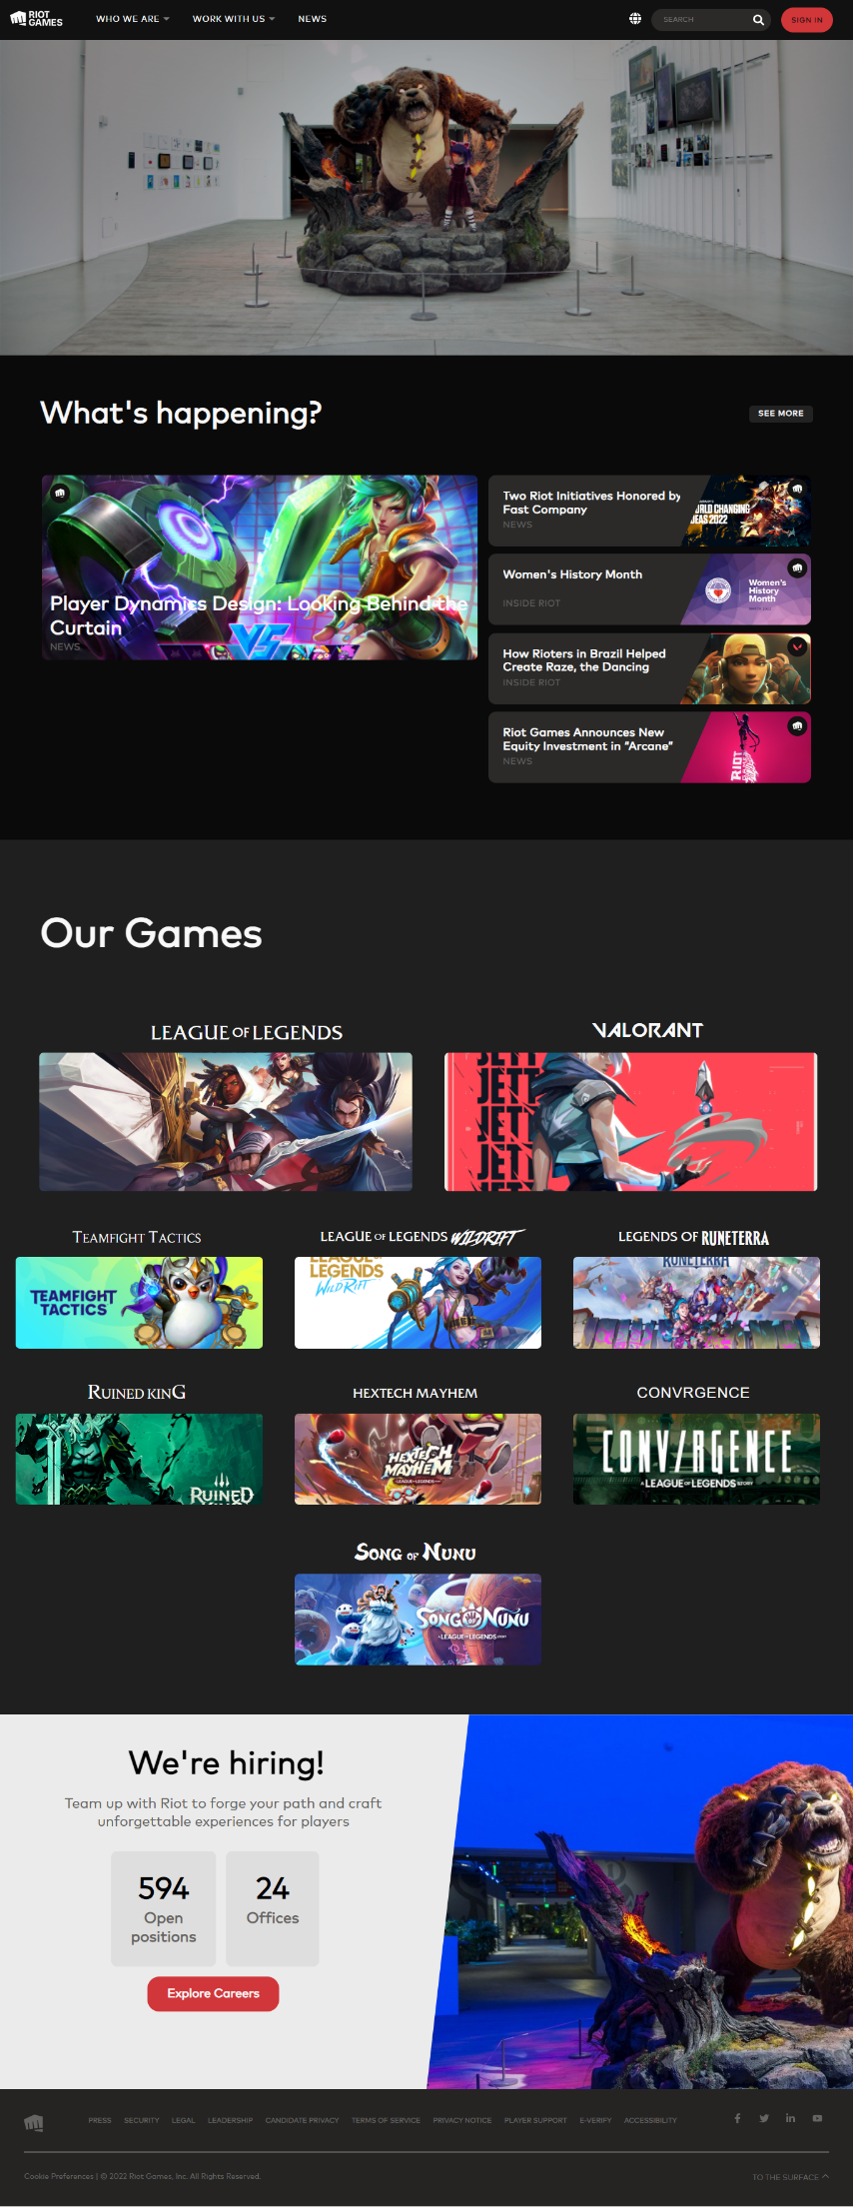

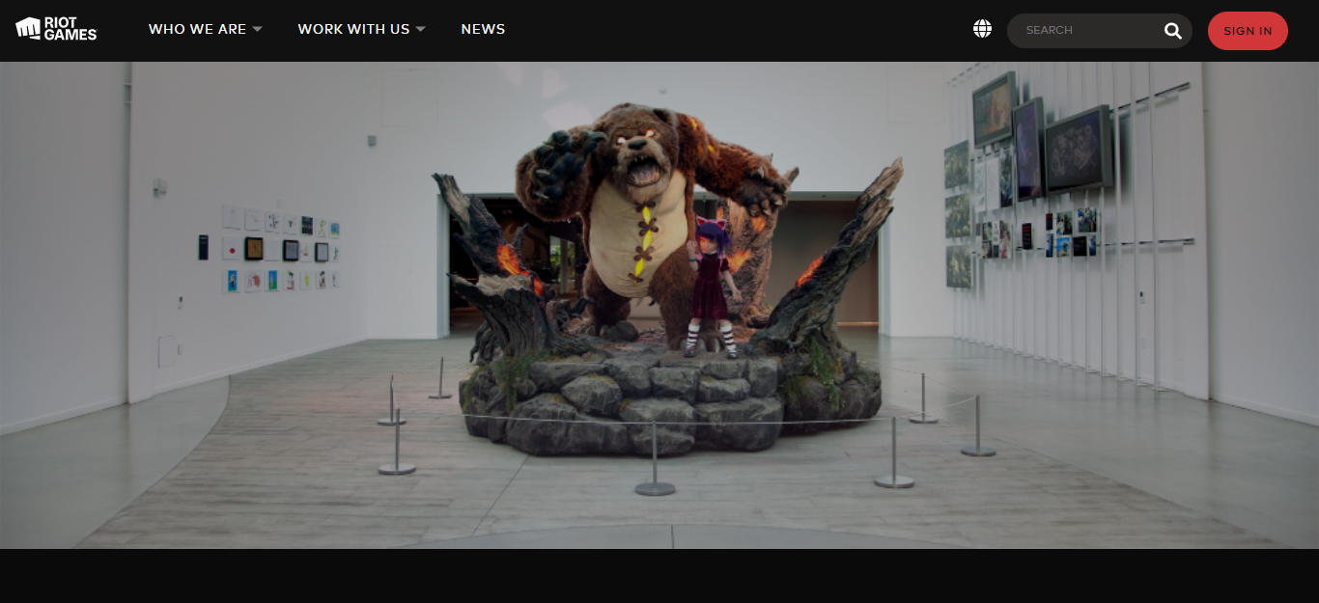

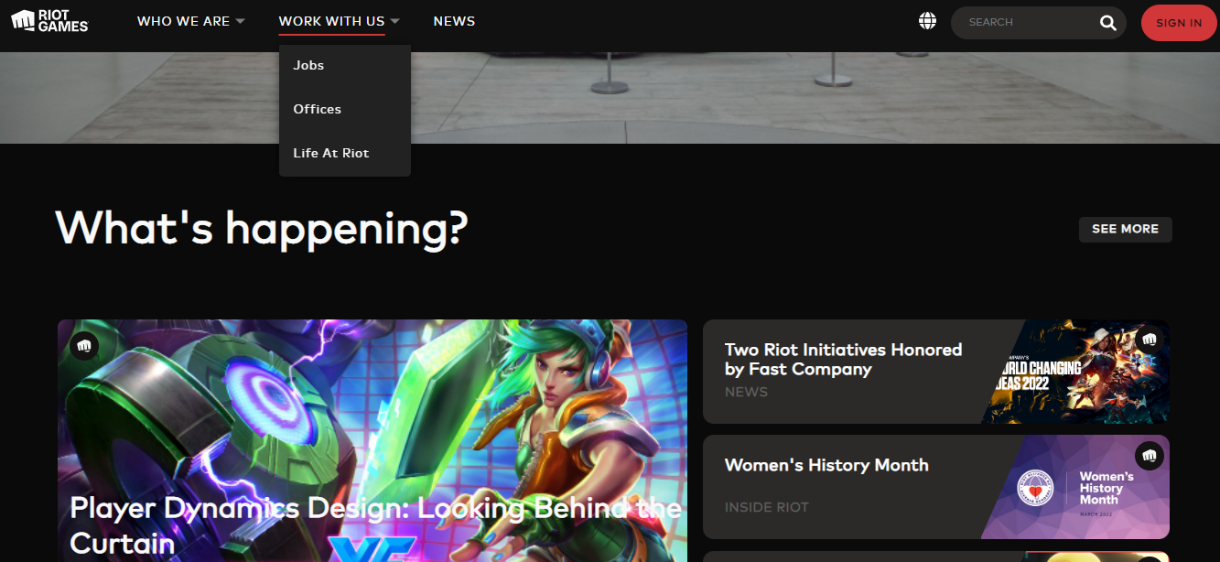

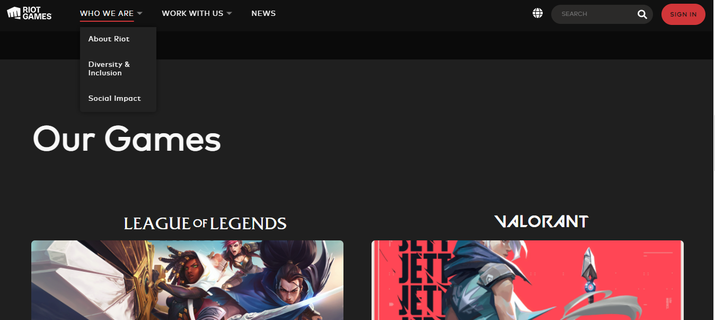

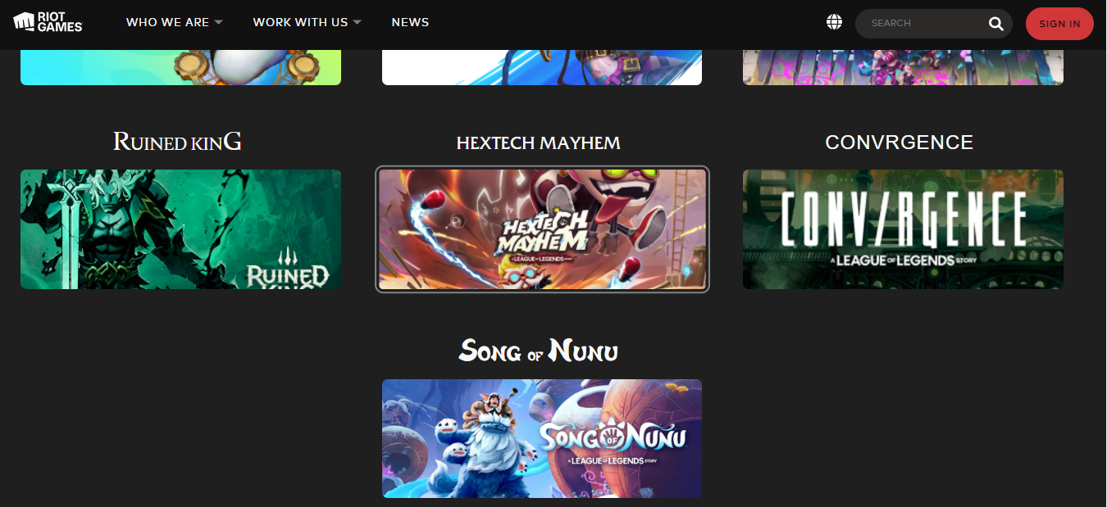

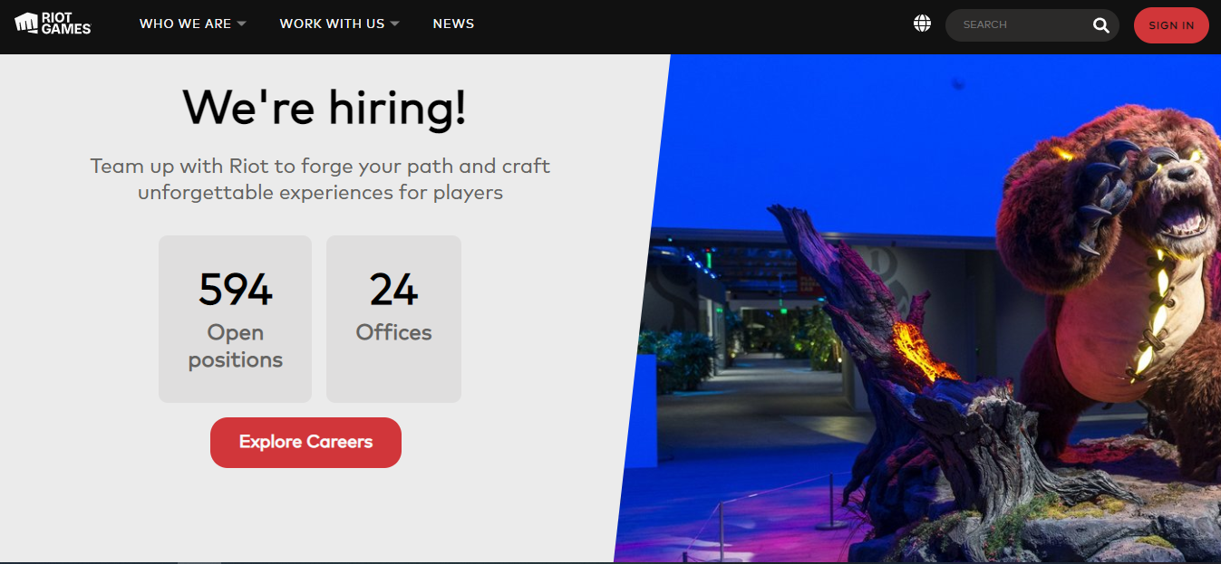

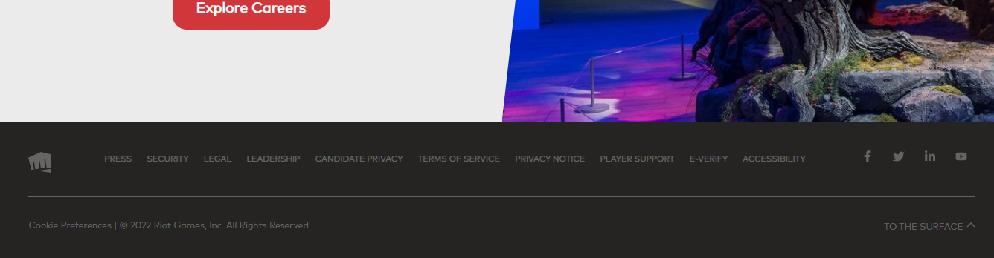

REGISTRATION PAGE :

**registration.html :**

<!DOCTYPE html>

<html lang="en">

<head>

    <meta charset="UTF-8">

    <meta http-equiv="X-UA-Compatible" content="IE=edge">

    <meta name="viewport" content="width=device-width, initial-scale=1.0">

    <title>Riot | Registration</title>

    <link rel="stylesheet" href="../css/registration/registration.css" />

    <link rel="shortcut icon" href="../static/favicon.ico" type="image/x-icon">

</head>

<body>

    <div class="container">

        <form class="registration-card" name="userDetails">

            <p>Registration</p>

            <div class="form_group_slideUp">

                <input type="text" name="fname" id="fname" placeholder="First Name" required />

                <label for="fname">First Name</label>

                <p id="fname-error"></p>

            </div>

            <div class="form_group_slideUp">

                <input type="text" name="lname" id="lname" placeholder="Last Name" required />

                <label for="lname">Last Name</label>

                <p id="lname-error"></p>

            </div>

            <div class="form_group_slideUp">

                <input type="text" id="uname" name="uname" placeholder="Username" required />

                <label for="uname">Username</label>

                <p id="uname-error"></p>

            </div>

            <div class="form_group_slideUp">

                <input type="email" name="email" id="email" placeholder="E-mail" autocomplete="email" required />

                <label for="email">E-mail</label>

            </div>

            <div class="form_group">

                <label for="gender">Gender</label>

                <div class="gender-values">

                    <input type="radio" name="gender" id="male" value="male" />

                    <label for="male">Male</label>

                    <input type="radio" name="gender" id="female" value="female" />

                    <label for="female">Female</label>

                </div>

            </div>

            <div class="form_group_slideUp">

                <input type="date" name="dob" id="dob" required />

                <label for="dob">Date of Birth</label>

            </div>

            <div class="form_group_slideUp">

                <input type="text" name="age" id="age" placeholder="Age" disabled required />

                <label for="age">Age</label>

                <p id="age-error"></p>

            </div>

            <div class="form_group_slideUp">

                <input type="password" name="password" id="password" placeholder="Password" required />

                <label for="password">Password</label>

                <p id="password-error"></p>

            </div>

            <div class="form_group_slideUp">

                <input type="password" name="confirmPassword" id="confirm-password" placeholder="Confirm Password"

                    disabled required />

                <label for="confirm-password">Confirm Password</label>

                <p id="confirm-password-error"></p>

            </div>

            <div class="form_group_slideUp">

                <input type="text" name="phNo" id="ph-no" autocomplete="mobile" maxlength="10"

                    placeholder="Phone Number" />

                <label for="ph-no">Phone Number</label>

            </div>

            <div class="agree-to-rules">

                <input type="checkbox" name="agree" id="agree" />

                <label for="agree">I abide all the rules & regulations, also I ensure to provide my credentials when

                    mandatory.</label>

            </div>

            <div class="register-btn">

                <input type="submit" name="register" id="register" value="REGISTER" disabled />

            </div>

        </form>

    </div>

</body>

<script src="../js/registration.js"></script>

</html>

**registration.css :**

@charset "UTF-8";

@font-face {

  font-family: "Mark Pro";

  src: url(../../fonts/FontFont_FF.Mark.Pro.otf) format("opentype");

}

* {

  margin: 0;

  padding: 0;

  box-sizing: border-box;

  font-family: "Mark Pro", Arial, Helvetica, sans-serif;

}

body {

  display: flex;

  justify-content: flex-end;

  margin: 0 2%;

  background: url(../../static/registration/valo-7.png) repeat;

}

::-webkit-calendar-picker-indicator {

  filter: invert(1);

}

input:disabled {

  background: rgba(97, 95, 95, 0.2) !important;

  cursor: default !important;

}

input[type=submit]:disabled {

  background: rgba(97, 95, 95, 0.2) !important;

  cursor: default !important;

  border: none !important;

  color: #fff !important;

}

.container {

  z-index: 999;

  margin: 2rem 0;

  border-radius: 5px;

  box-shadow: 0 0.5rem 1.5rem rgba(0, 0, 0, 0.8);

  padding: 2rem;

  width: fit-content;

  background: url(../../static/registration/explore-hero-bg--large.jpg);

}

.container .registration-card>.register-btn {

  text-align: center;

}

.container .registration-card>.register-btn input {

  margin-top: 1.5rem;

  background: #d13639;

  color: #fcf8f8;

  border: 1px solid #d13639;

  border-radius: 5px;

  padding: 0.5rem 1.4rem;

  font-size: 1rem;

  cursor: pointer;

  transition: all 0.2s ease-in-out;

}

.container .registration-card>.register-btn input:hover {

  background: #fefefe;

  color: #d13639;

  border: 1px solid #d13639;

}

.container .registration-card>div {

  margin-bottom: 1rem;

}

.container .registration-card>.form_group {

  color: gray;

  margin: 1.6rem 0;

}

.container .registration-card>.form_group>label {

  font-size: 1.1rem;

}

.container .registration-card>.form_group>.gender-values {

  margin: 0.8rem 0;

  display: flex;

  align-items: center;

}

.container .registration-card>.form_group>.gender-values>label {

  padding-right: 1rem;

  cursor: pointer;

}

.container .registration-card>.form_group>.gender-values>input[type=radio] {

  cursor: pointer;

  margin-right: 4px;

  appearance: none;

  width: 1.1rem;

  height: 1.1rem;

  border: 2px solid #d13639;

  border-radius: 50%;

  background-clip: content-box;

  transition: all 300ms;

}

.container .registration-card>.form_group>.gender-values>input[type=radio]:checked {

  width: 0.95rem;

  height: 0.95rem;

  background: #d13639;

}

.container .registration-card>p {

  display: inline-block;

  font-size: 2rem;

  font-family: "Franklin Gothic Medium", "Arial Narrow", Arial, sans-serif;

  color: #fefefe;

  text-transform: uppercase;

  position: relative;

  left: 50%;

  transform: translateX(-50%);

}

.container .registration-card>p::after {

  content: "";

  position: absolute;

  bottom: -1px;

  left: 50%;

  transform: translateX(-50%);

  width: 105%;

  height: 2px;

  background: #d13639;

}

.container .registration-card .form_group_slideUp {

  position: relative;

  width: 100%;

  padding: 15px 0 0;

  margin-top: 10px;

}

.container .registration-card .form_group_slideUp>#age-error {

  margin-top: 0.7rem;

  color: #d13639;

}

.container .registration-card .form_group_slideUp>#fname-error {

  margin-top: 0.7rem;

  color: #d13639;

}

.container .registration-card .form_group_slideUp>#lname-error {

  margin-top: 0.7rem;

  color: #d13639;

}

.container .registration-card .form_group_slideUp>#uname-error {

  margin-top: 0.7rem;

  color: #d13639;

}

.container .registration-card .form_group_slideUp>#confirm-password-error {

  margin-top: 0.7rem;

  color: #d13639;

}

.container .registration-card .form_group_slideUp>#password-error {

  margin-top: 0.7rem;

  color: #d13639;

}

.container .registration-card .form_group_slideUp>input {

  width: 100%;

  border: 0;

  border-bottom: 1px solid #fefefe;

  outline: none;

  font-size: 1.1rem;

  color: #fefefe;

  padding: 7px 0;

  background: transparent;

  transition: border-color 0.2s;

}

.container .registration-card .form_group_slideUp>input::placeholder {

  color: transparent;

}

.container .registration-card .form_group_slideUp>input:placeholder-shown~label {

  font-size: 1.1rem;

  cursor: text;

  top: 20px;

}

.container .registration-card .form_group_slideUp>input:focus {

  padding-bottom: 6px;

  border-bottom: 2px solid #d13639;

}

.container .registration-card .form_group_slideUp>input:focus~label {

  position: absolute;

  top: 0;

  display: block;

  transition: 0.2s;

  font-size: 0.8rem;

  color: gray;

}

.container .registration-card .form_group_slideUp>label {

  position: absolute;

  top: 0;

  display: block;

  transition: 0.2s;

  font-size: 0.8rem;

  color: gray;

}

.container .registration-card>.agree-to-rules {

  color: #fefefe;

  user-select: none;

  display: flex;

  align-items: center;

}

.container .registration-card>.agree-to-rules>input {

  cursor: pointer;

}

.container .registration-card>.agree-to-rules>input[type=checkbox] {

  margin-right: 0.6rem;

  appearance: none;

  position: relative;

  width: 1.2rem;

  height: 1.2rem;

  border: 2px solid #d13639;

  background-clip: content-box;

  padding: 3px;

}

.container .registration-card>.agree-to-rules>input[type=checkbox]:checked {

  transition: all 100ms ease-in-out;

  background: #d13639;

}

.container .registration-card>.agree-to-rules>input[type=checkbox]:checked::after {

  font-size: 1rem;

  content: "✓";

  color: #fefefe;

  position: absolute;

  top: 50%;

  left: 50%;

  transform: translate(-50%, -50%);

}

.container .registration-card>.agree-to-rules>label {

  cursor: pointer;

}

**registration.js :**

const getAge = document.getElementById('age');

const getDob = document.getElementById('dob');

const getFName = document.getElementById('fname');

const fNameErrorDisplay = document.getElementById('fname-error');

const getLName = document.getElementById('lname');

const lNameErrorDisplay = document.getElementById('lname-error');

const getUName = document.getElementById('uname');

const uNameErrorDisplay = document.getElementById('uname-error');

const getPassword1 = document.getElementById('password');

const getPassword2 = document.getElementById('confirm-password');

const password1ErrorDisplay = document.getElementById('password-error');

const password2ErrorDisplay = document.getElementById('confirm-password-error');

const getGender = document.querySelectorAll('input[name=gender]');

const ageErrorDisplay = document.getElementById('age-error');

const registerBtn = document.getElementById('register');

const getForm = document.querySelector('.registration-card');

const agreeBtn = document.getElementById('agree');

let fnameValid = lnameValid = unameValid = pass1Valid = pass2Valid = dobValid = genderValid = agreeValid = false;

getFName.addEventListener('keyup', () => {

    const nameRegex = /^[a-zA-Z ]+$/;

    const fName = getFName.value;

    if (!nameRegex.test(fName)) {

        fNameErrorDisplay.innerHTML = 'First Name should be alphabetical';

        return false;

    }

    else

        fNameErrorDisplay.innerHTML = '';

    console.log(getFName.value);

    if (getFName.value == '')

        fNameErrorDisplay.innerHTML = '';

    fnameValid = true;

    shallEnableChecker();

});

getLName.addEventListener('keyup', () => {

    const nameRegex = /^[a-zA-Z ]+$/;

    const lName = getLName.value;

    if (!nameRegex.test(lName)) {

        lNameErrorDisplay.innerHTML = 'Last Name should be alphabetical';

        return false;

    }

    else

        lNameErrorDisplay.innerHTML = '';

    if (getLName.value === '')

        LNameErrorDisplay.innerHTML = '';

    lnameValid = true;

    shallEnableChecker();

});

// User Name Validation - At least 6 characters, no special characters

getUName.addEventListener('keyup', () => {

    let error = '';

    const uName = getUName.value;

    const uNameRegex = /^[a-zA-Z0-9]{6,}$/;

    if (uName.length < 6)

        error += 'User Name should be atleast 6 characters<br/>';

    if (!uNameRegex.test(uName))

        error += 'User Name should be alphanumeric<br/>';

    if (error) {

        uNameErrorDisplay.innerHTML = error;

        return false;

    }

    else

        uNameErrorDisplay.innerHTML = '';

    if (uName.value === '')

        uNameErrorDisplay.innerHTML = '';

    unameValid = true;

    shallEnableChecker();

});

for (const eachGender of getGender) {

    eachGender.addEventListener('change', () => {

        if (eachGender.checked) {

            // console.log(eachGender.value);

            genderValid = true;

            shallEnableChecker();

        }

    });

}

getDob.addEventListener('change', () => {

    const dob = new Date(getDob.value);

    const ageDifMs = Date.now() - dob.getTime();

    const ageDate = new Date(ageDifMs);

    let age = ageDate.getUTCFullYear() - 1970;

    getAge.value = age > 0 ? age : 0;

    if (getAge.value < 16) {

        ageErrorDisplay.innerHTML = 'You must be atleast 16';

        registerBtn.disabled = true;

        return false;

    }

    else

        ageErrorDisplay.innerHTML = '';

    dobValid = true;

    shallEnableChecker();

});

// Password - At least 8 characters, atleast one special character and one number

getPassword1.addEventListener('keyup', () => {

    let errorMsg = '';

    const password = getPassword1.value;

    const alphaRegexp = new RegExp('[a-zA-Z]', 'g');

    const numericRegexp = new RegExp('[0-9]', 'g');

    const specialRegexp = new RegExp('[^a-zA-Z0-9 ]', 'g');

    let specialCharacterCount = 0;

    let numericCount = 0;

    let alphaCount = 0;

    for (let match of password.matchAll(alphaRegexp))

        alphaCount++;

    for (let match of password.matchAll(numericRegexp))

        numericCount++;

    for (let match of password.matchAll(specialRegexp))

        specialCharacterCount++;

    if(getPassword2.value && (getPassword1.value !== getPassword2.value)) {

        password2ErrorDisplay.innerHTML = 'Passwords do not match';

        registerBtn.disabled = true;

        return false;

    }

    else

        password2ErrorDisplay.innerHTML = '';

    if (password.length > 7 && alphaCount > 0 && numericCount > 0 && specialCharacterCount > 0) {

        password1ErrorDisplay.innerHTML = '';

        getPassword2.disabled = false;

        getPassword2.style.background = 'none';

        pass1Valid = true;

    }

    else {

        if (password.length < 8)

            errorMsg += 'Password should be atleast 8 characters<br>';

        if (alphaCount == 0)

            errorMsg += 'Password should contain atleast one alphabet<br>';

        if (numericCount == 0)

            errorMsg += 'Password should contain atleast one numeric value<br>';

        if (specialCharacterCount == 0)

            errorMsg += 'Password should contain atleast one special character<br>';

        password1ErrorDisplay.innerHTML = errorMsg;

        getPassword2.disabled = true;

        getPassword2.background = 'rgba(97, 95, 95, 0.2)';

        return false;

    }

    if (getPassword1.value === '')

        password1ErrorDisplay.innerHTML = '';

    shallEnableChecker();

});

getPassword2.addEventListener('keyup', () => {

    if (getPassword1.value != getPassword2.value) {

        password2ErrorDisplay.innerHTML = 'Passwords do not match';

        registerBtn.disabled = true;

        return false;

    }

    else

        password2ErrorDisplay.innerHTML = '';

    if (getPassword2.value === '')

        password2ErrorDisplay.innerHTML = '';

    pass2Valid = true;

    shallEnableChecker();

});

agreeBtn.addEventListener('change', () => {

    if (agreeBtn.checked)

        agreeValid = true;

    else

        agreeValid = false;

    shallEnableChecker();

})

// Age - At least 16 years old

const shallEnableChecker = () => {

    // console.log(genderValid);

    if (fnameValid && lnameValid && unameValid && pass1Valid && pass2Valid && dobValid && genderValid && agreeValid)

        registerBtn.disabled = false;

    else

        registerBtn.disabled = true;

}

getForm.addEventListener('submit', (e) => {

    e.preventDefault();

});

**OUTPUT :**

